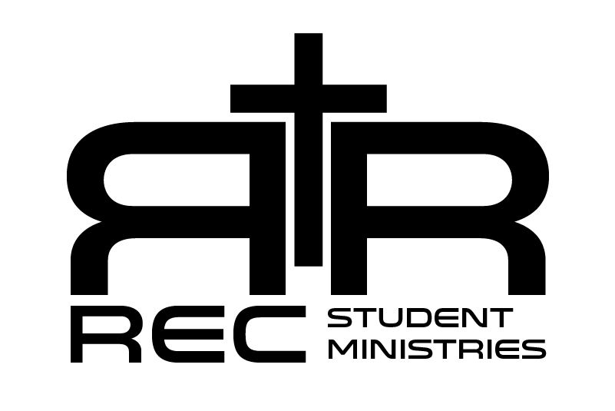 | 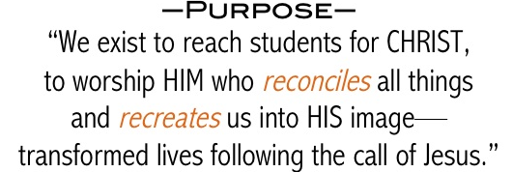

Spring and Summer 2019 (March – August)

Sunday Night Group (5:00pm – Worship Practice; 6:00pm-8:00pm)
- Games, Worship, Lesson, Guys & Girls Small Group Time

Wednesday Night Group (6:45pm-8:00pm)
- Food and Discussion/Study on Apologetics (Awana Curriculum)

______________________________________________________________________________

Two Major Events
Contact Pastor Jacob for more information @ Jacob@fbcspringfield.org

- Youth/Young Adult Mission Trip
Date: April 14th-19th 2019
Location: Graffiti Ministries – 2811 Mermaid Ave. Brooklyn, NY 11224

- Student MFuge Camp
Date: July 7th-12th 2019
Location: Carson-Newman University in Jefferson City, TN

______________________________________________________________________________

March
3rd (Sunday) – Philippians 4:10-23 (Parent Meeting)
6th (Wednesday) – Student Sponsored Spaghetti Dinner
10th (Sunday) – Daniel 1-2
13th (Wednesday) – Apologetics – Discussion on Authority
17th (Sunday) – Daniel 3-4
20th (Wednesday) – Apologetics – Discussion on Evil
24th (Sunday) - Daniel 5-6
27th (Wednesday) – Apologetics – Discussion on Falsehood
31st (Sunday) – Scavenger Hunt

April
3rd (Wednesday) – Apologetics – Discussion on Suffering
7th (Sunday) - Daniel 7-8
10th (Wednesday) – Apologetics – Discussion on Hell
14th-19th (Sunday – Friday) - Mission Trip to Graffiti New York
21st (Sunday) - Daniel 9-10
24th (Wednesday) – Apologetics – Discussion on Love
28th (Sunday) - Youth Fundraiser

May
1st (Wednesday) – Apologetics – Discussion on Questions
4th (Saturday) - Neighborhood Service Project (Spring Cleaning)
5th (Sunday) - Youth Thrive Event
8th (Wednesday) – Apologetics – Discussion on Doubt
12th (Sunday) – Daniel 11-12
15th (Wednesday) – Apologetics – Discussion on Challenges
19th (Sunday) – Go Bowling
22nd (Wednesday) – Apologetics – Review of Year
26th (Sunday) – Hebrews 1-2
29th (Wednesday) – Student Sponsored Dinner

June
2nd (Sunday) – Hebrews 3-4
9th (Sunday) – Awana Awards Night
16th (Sunday) – Out Break Game Night
23rd (Sunday) – Hebrews 5-6
30th (Sunday) - Hebrews 7-8
July
8th-12th (Monday – Friday) – Mfuge Camp @ Carson-Newman University
14th (Sunday) – Hebrews 9-10
21st (Sunday) – Hebrews 11-12
28th (Sunday) – Student Sponsored FBC Talent Show

August
4th (Sunday) – Hebrews 13
11th (Sunday) – Flight Trampoline Park
18th (Sunday) – Bring a Friend Night/Game Night
25th (Sunday) – 1 John 1

